**Universidad de las Fuerzas Armadas ESPE**

**Members:** Gallardo Juan, Hidrobo Nicolás, Lara Nicole, Maranje Cristian.

**NRC:** 3248

**Object-Oriented Programming**

**Specification of Requirements according to the standard from IEEE830**

**Proyect: University Restaurant Capacity Control System**

**1 Introduction**

This document is a Software Requirement Specification (ERS) for the People Control System in a university bar. This specification has been structured based on the guidelines given by the IEEE 830, 1998 standard. It seeks to establish the foundations and bases for the development of the software that is in accordance with this document, guaranteeing compliance with the requirements initially raised.

**1.1 Purpose**

The purpose of this document is to define functional and non-functional specifications for the development of a people control and management system for edible products in a university bar. Which will be used by students, teachers and those in charge of the bar. However, since its application is based on a commercial area, it is not limited to being implemented only in universities but in any commercial plaza that is related to the commercialization of products within an inventory that requires generation of invoices and assignment of shifts and tables.

**1.2 System scope**

University Capacity Control is a system aimed at the user of the system; it will help solve the current problem of covid 19 by distancing people in a place that is very frequented by all kinds of people at the university. This project aims to manage people, orders and products in a university bar.

**1.3 Involved personnel**

|  |  |
| --- | --- |
| **Name** | Juan Gallardo |
| **Role** | Analyst, designer and programmer |
| **Professional Category** | Software engineering student |
| **Responsibility** | Information analysis, design and programming of the System |
| **Contact Information** | jegallardo@espe.edu.ec |

|  |  |
| --- | --- |
| **Name** | Nicolás Hidrobo |
| **Role** | Analyst, designer and programmer |
| **Professional Category** | Software engineering student |
| **Responsibility** | Information analysis, design and programming of the System |
| **Contact Information** | anhidrobo@espe.edu.ec |

|  |  |
| --- | --- |
| **Name** | Nicole Lara |
| **Role** | Analyst, designer and programmer |
| **Professional Category** | Software engineering student |
| **Responsibility** | Information analysis, design and programming of the System |
| **Contact Information** | nalara1@espe.edu.ec |

|  |  |
| --- | --- |
| **Name** | Cristian Maranje |
| **Role** | Analyst, designer and programmer |
| **Professional Category** | Software engineering student |
| **Responsibility** | Information analysis, design and programming of the System |
| **Contact Information** | ccmaranje@espe.edu.ec |

**1.4.Definitions, acronyms and abbreviations.**

|  |  |
| --- | --- |
| **Name** | **Description** |
| **User** | **Person who will use the system to manage processes.** |
| **SIS-I** | **Web Information System for the Management of Administrative and Academic Processes.** |
| **ERS** | **Software Requirements Specification.** |
| **FR** | **Functional Requirement.** |
| **RNF** | **Non-functional requirement.** |
| **FTP** | **File Transfer Protocol.** |
| **Moodle** | **Virtual classroom.** |

**1.5 Reference**

|  |  |
| --- | --- |
| **Document Title** | **Reference** |
| **Standard IEEE 830 - 1998** | **IEEE** |

**1.6.Reference**

IEEE(03 January 2021) Specification of Requirements by IEEE 830 obtained from:https://www.fdi.ucm.es/profesor/gmendez/docs/is0809/ieee830.pdf

**1.7 Summary.**

This document consists of three sections. The first section introduces it and provides an overview of the system resource specification.

In the second section of the document, a general description of the system is made, in order to know the main functions that it must perform, the associated data and the factors, restrictions, assumptions and dependencies that affect development, without going into excessive detail.

**2.General Description.**

It is here where this program offers a control alternative that allows to take full advantage of the technological factor in activities commonly carried out by people but that can be automated in order to make better use of the human factor used for activities that are really necessary as the management of a system that stores a database of clients with information about them as well as orders made over a period of time, and has shifts assigned within available tables that allow to have a default configuration section to generate positions that guarantee social distancing.

**2.1 Product Perspective**

The purpose of this software system offers a capacity and inventory control that can be adapted to different contexts of a changing commercial world, unlike most existing programs that are only focused on the current reality but not in the future in the conditions are determined by external factors such as a global health emergency.

The versatility of functions that the future software will have will allow it to adapt to cash control programs, billing, data registration, among others, such as those that commonly affect a large part of businesses today, since this software does not influence these characteristics if not rather complements them by adding extra information and additional functionalities.

Although this system is focused on improving the customer experience of a restaurant, it is not thinking of its present version to interact directly with customers, but rather through an intermediary, which in this case is the restaurant's employees and administrators. It is not oriented or adapted to a friendly interface for a general user or to be coupled to devices that facilitate its reach to a more general public. Its main objective is to serve small or large companies to have a better control of their commercial activities.

**2.2 Product Functions.**

The University Restaurant Capacity Control System will regulate and warn about violation of the capacity conditions allowed in the specifications of its configuration, the system will notify and anticipate both the restaurant employees and the customers about the availability of people who can enter.

For clients:.

The system will generate a random location between the tables that meet the minimum distance specifications defined in their previous configuration, thus guaranteeing the correct positioning between clients.

In order to guarantee a correct flow of people within the facilities, which will be indispensable for the availability of tables to be a test, this program will have a timer function that will notify both the client and the collaborator of the time limit that has been set. intended for a table in use.

For the restaurant:

This system will allow an independent inventory program to be carried out from information supplied to a not very extensive database that will allow the program to provide better control of:

* Inputs and acquisition of products as raw material
* Departure and sale of products present in a menu.
* Availability or exhaustion of products
* Maximum inventory capacity according to the conditions defined by an administrator according to the agreement for the business conditions

This information defined by the program can be reviewed and exported by a specific administrator in order to reproduce the data generated in a more formal report.

**2.1.1 Function Relationship**

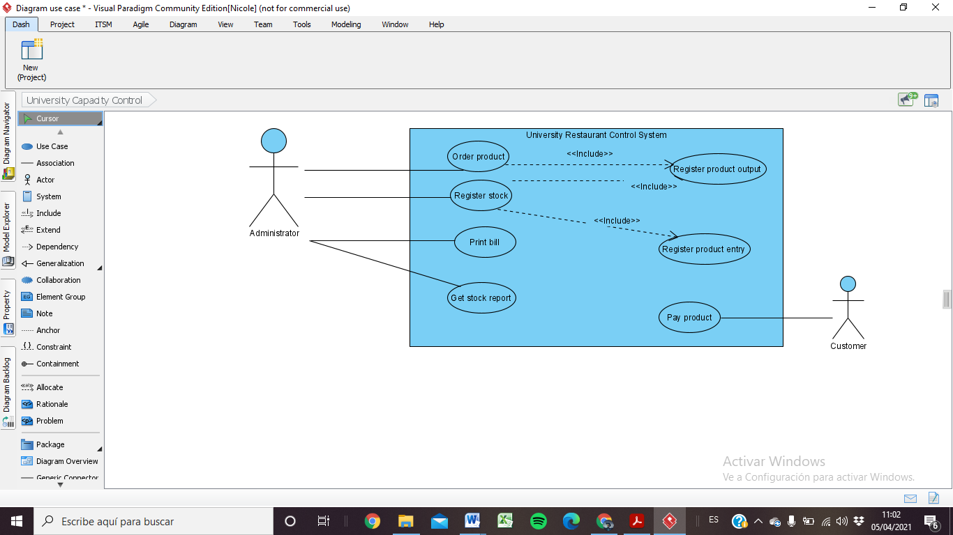

**2.3 Users Characteristics.**

|  |  |
| --- | --- |
| Type of User | System administrator |
| Professional training | Business manager |
| Activities | -Authorizes the change or new entry of data on a product  -Manages and defines the default configurations of the system |

|  |  |
| --- | --- |
| Type of User | Business collaborator |
| Professional training | Restaurant assistant |
| Activities | -Manipulates the system to provide information to the client or administrator  -Gives shifts and assigns positions to the client  -Registers entries and exits of products to inventory |

|  |  |
| --- | --- |
| Type of User | Customer |
| Professional training | Undefined |
| Activities | -Choose a room to which a positionit should be assigned  -Request through a restaurant employee a table or an assignment shift |

**2.4 Restrictions**

The restrictions for the software developers are the following:

* Hardware limitations: the software must run in a low-end machine so it must be easy to run.
* Ability requirements: the developing team needs to have a minimum to medium knowledge to be able to create the software.
* Programming language: the software has to be made in java language and in the NetBeans IDE software.

**2.5 Dependencies and suppositions**

The software is going to be developed for the restaurant at the “ESPE” University, for the control of the tables and seats that are inside and outside of the restaurant, it will have a record of the menu of the restaurant, it complies with the most recent biosecurity protocols in Ecuador.

**3 .-Specific requirements**

**3.1 External Interfaces**

* The implementation of the system requires a compatible hardware component that has a screen that provides visibility and clarity since certain functionalities depend on and are based on the correct visualization of both the user and the system administrator.
* The system itself will depend on a previously installed compatible operating system that allows the development of the necessary tools for the system to work.
* The system will have an interactive interface based on a command line available for which it is necessary to have a hardware team that allows its control

**Functional requirement 1**

The cashier registers the order of the customer in the system.

|  |  |
| --- | --- |
| Requirement identification | FR01 |
| Requirement Name | Order |
| Characteristics | The order is registered in the system. |
| Requirement description | Register a placed order |
| Non-functional requirement |  |
| Requirement priority | High |

**Functional requirement 2**

The system will allow to create, delete and edit an order.

|  |  |
| --- | --- |
| Requirement identification | FR02 |
| Requirement Name | Order editor |
| Characteristics | The order can be created, changed or deleted. |
| Requirement description | Add or remove orders from the database. |
| Non-functional requirement |  |
| Requirement priority | High |

Functional requirement 3

The system will increase and decrease the amount of product in stock.

|  |  |
| --- | --- |
| Requirement identification | FR03 |
| Requirement Name | Stock actualization |
| Characteristics | Edits the totals in the stocks. |
| Requirement description | Add or remove products from the database depending on their availability |
| Non-functional requirement |  |
| Requirement priority | High |

Functional requirement 4

The system will keep track of the expiration date of the products.

|  |  |
| --- | --- |
| 05Requirement identification | FR04 |
| Requirement Name | Expiration dates |
| Characteristics | Checks the date of the products |
| Requirement description | Generate a low quantity warning for a product |
| Non-functional requirement |  |
| Requirement priority | Medium |

Functional requirement 5

The system keeps track of the viable seats

|  |  |
| --- | --- |
| Requirement identification | FR05 |
| Requirement Name | Availability |
| Characteristics | Checks if the seats are empty. |
| Requirement description | Show table availability |
| Non-functional requirement |  |
| Requirement priority | High |

Non-functional requirement 1

The system will have an interface that is easy to use for the cashier

|  |  |
| --- | --- |
| Requirement identification | NFR01 |
| Requirement Name | Interface |
| Characteristics | Easy to use |
| Requirement description | The interface will have a low amount of clutter. |
| Requirement priority | Medium |

Non-functional requirement 2

The system is going to realize all of the process in the minimum time possible

|  |  |
| --- | --- |
| Requirement identification | NFR02 |
| Requirement Name | Response time |
| Characteristics | The system loads and realizes orations quickly. |
| Requirement description | Throw exceptions that allow error checking. |
| Requirement priority | Medium |

**3.3. Requisitos de Rendimiento**

* It is required to generate some files from the database beforehand as flat files so as not to affect the search option with empty searches of a maximum of 3 files.
* The maximum number of system administrator users is one.
* The system can be implemented in several computers without affecting your requirements with up to three terminals with shared information at the same time.
* A flat file is established that can store up to hundreds of instances without generating

compilation and search problems

.

**3.4 Design restrictions.**

* The system is implemented for a displayed console of standard size of electronic equipment up to 23 inches that does not distort the images and impressions per console displayed.
* The administrator and user interface cannot be customizable in any way since it exchanges information directly with

the other equipment in operation.

* Preferably the following characteristics •

Network adapters.

• 1.66GHz processor or higher.

• Minimum memory of 256Mb.

• Mouse.

•Keyboard

**3.5. Atributos del Sistema**

Se detallar´an los atributos de calidad (las “ilities”) del sistema: Fiabilidad, mantenibilidad, portabilidad, y, muy importante, la seguridad. Deber´a especificarse qu´e tipos de usuario est´an autorizados, o no, a realizar ciertas tareas, y c´omo se implementar´an los mecanismos de seguridad (por ejemplo, por medio de un login y una password). 3.6. Otros Requisitos Cualquier otro requisito que no encaje en otra secci´on. 4. Ap´endices Pueden contener todo tipo de informaci´on relevante para la ERS pero que, propiamente, no forme parte de la ERS. Por ejemplo: 1. Formatos de entrada/salida de datos, por pantalla o en listados. 2. Resultados de an´alisis de costes. 3. Restricciones acerca del lenguaje de programaci´on.

**3.5. System Attributes**

Being a control system that facilitates the manipulation of existing data, it must be based on the principles of reliability, maintainability, portability and security.

**Reliability .-** the generation of flat files and the database is instantaneous therefore the system can be trusted to register large inventories filled with products with different characteristics.

**Portability** .- the system was programmed in Java so that its executability can be given on any computer with the Java extensions installed

**Security .-** The program functions are stored in private variables that allow the encapsulation of the code, in turn, a login record that requests the username and password can be implemented, stored in another database with previously registered clients.

**Maintainability** .- The code is defined in order centered on the classes that allow the change and update of the classes during their periodic maintenance without altering the other functions that do not require changing.

**4. Appendices**

Data input and output format per screen:

1. NEW ORDER

2. PRINT All ORDERS

3. ADD PRODUCT

4. ADD COSTUMER

5. FIND PRODUCT

6. SHOW PRODUCTS

7. EXIT

1

COSTUMER ID: 175758963

NOT FOUND :(

ENTER COSTUMER NAME:Ricardo

ENTER COSTUMER MAIL:Lopez

ENTER COSTUMER ID: 1748256598

SAVED :)

COSTUMER ID: _